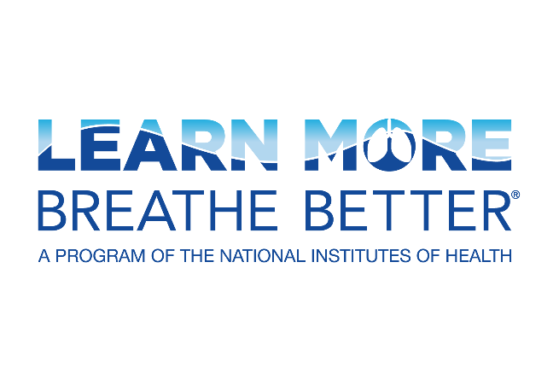

# **Lung Disease Sample Social Media Posts**

Share these sample posts on your social media channels to raise awareness about lung diseases.

## Acute Respiratory Distress Syndrome (ARDS)

Acute respiratory distress syndrome (ARDS) is a serious condition in which fluid and pus build up in the air sacs of the lungs. This prevents enough oxygen from passing into the lungs and bloodstream. Learn more about ARDS from @BreatheBetter: <https://www.nhlbi.nih.gov/resources/what-acute-respiratory-distress-syndrome-ards-fact-sheet>

ARDS usually occurs in people who are already ill due to another disease or a major injury. The most common underlying risk factor of ARDS is infection, like COVID-19, pneumonia, or sepsis. Learn more about ARDS from @BreatheBetter: <https://www.nhlbi.nih.gov/resources/what-acute-respiratory-distress-syndrome-ards-fact-sheet>

## Alpha-1 Antitrypsin (AAT) Deficiency

Alpha-1 antitrypsin (AAT) deficiency symptoms may include:

* Shortness of breath
* Repeated lung infections
* Tiring quickly when exercising

Learn more in this fact sheet from @BreatheBetter and @AlphaFriend: <https://www.nhlbi.nih.gov/resources/what-alpha-1-antitrypsin-aat-deficiency-fact-sheet>

Alpha-1 antitrypsin (AAT) deficiency can increase the risk of liver and lung diseases. Learn about risk factors and how to manage this condition in this fact sheet from @BreatheBetter and @AlphaFriend: <https://www.nhlbi.nih.gov/resources/what-alpha-1-antitrypsin-aat-deficiency-fact-sheet>

## Asthma

Asthma is a chronic condition that causes coughing, wheezing, chest tightness, and shortness of breath. Although there's no cure for asthma, it can be controlled. Learn more about asthma from @BreatheBetter: <https://www.nhlbi.nih.gov/resources/lmbb-what-asthma-fact-sheet>

Your healthcare provider may diagnose you with asthma based on your medical history, physical exam, and tests. Your symptoms will help your provider determine if you have mild, moderate, or severe asthma. Learn more from @BreatheBetter: <https://www.nhlbi.nih.gov/resources/lmbb-what-asthma-fact-sheet>

## Bronchiectasis

Bronchiectasis is a lung condition that causes the airways to widen and scar. Some people are born with it, but more often, it happens to people who have certain conditions that injure the lungs. Learn more about bronchiectasis from @BreatheBetter: <https://www.nhlbi.nih.gov/resources/what-bronchiectasis-fact-sheet>

Bronchiectasis is a lung condition that causes the airways to widen and scar. Learn the facts about bronchiectasis from @BreatheBetter — including its signs and symptoms and ways to manage the condition after a diagnosis: <https://www.nhlbi.nih.gov/resources/what-bronchiectasis-fact-sheet>

## Chronic Obstructive Pulmonary Disease (COPD)

Common risk factors for COPD include a history of smoking, long-term exposure to lung irritants, and an inherited condition called Alpha-1 Antitrypsin Deficiency. Talk to your doctor about your lung health, and learn more about COPD from @BreatheBetter: <https://www.nhlbi.nih.gov/resources/copd-are-you-risk-fact-sheet>

By getting ahead of your COPD symptoms and talking about them with your healthcare provider regularly, you can put yourself on the path to a better quality of life. Learn more about how to live better with COPD from @BreatheBetter: <https://www.nhlbi.nih.gov/resources/copd-are-you-risk-fact-sheet>

## Cystic Fibrosis

Cystic fibrosis symptoms may include coughing with mucus or blood, joint or muscle pain, and salty-tasting skin. Learn more about cystic fibrosis and ways to manage this disease from @BreatheBetter: <https://www.nhlbi.nih.gov/resources/what-cystic-fibrosis-fact-sheet>

Cystic fibrosis affects the lungs and other organs, causing a buildup of mucus, which can lead to damage in the lungs and make it harder to breathe. This @BreatheBetter fact sheet describes the signs and symptoms of the disease and how it's managed: <https://www.nhlbi.nih.gov/resources/what-cystic-fibrosis-fact-sheet>

## Pneumonia

Pneumonia can affect people of any age. Older adults may experience weakness, confusion, or a lower-than-normal temperature. Babies may vomit, appear restless, have low energy, or show signs of breathing problems. Learn more from @BreatheBetter: <https://www.nhlbi.nih.gov/resources/what-pneumonia-fact-sheet>

Pneumonia can be mild or severe. Staying up to date on pneumococcus and flu vaccines can help prevent some types of pneumonia. Vaccines can also help decrease the severity for those who do get pneumonia. Learn more about pneumonia from @BreatheBetter: <https://www.nhlbi.nih.gov/resources/what-pneumonia-fact-sheet>

## Pulmonary Fibrosis

Pulmonary fibrosis occurs over time. It causes scarring deep in the lungs, which makes breathing difficult. It also makes it harder for oxygen to enter the bloodstream. Learn more about this disease from @BreatheBetter: <https://www.nhlbi.nih.gov/resources/what-pulmonary-fibrosis-fact-sheet>

Are you looking for information about pulmonary fibrosis? Learn about symptoms and disease management in this fact sheet from @BreatheBetter: <https://www.nhlbi.nih.gov/resources/what-pulmonary-fibrosis-fact-sheet>

## Sarcoidosis

Sarcoidosis symptoms may include shortness of breath, swollen lymph nodes, cough, fatigue, night sweats, and weight loss. It's more common in people over 55, women, African Americans, and Scandinavians. Learn more about sarcoidosis from @BreatheBetter: <https://www.nhlbi.nih.gov/resources/what-sarcoidosis-fact-sheet>

There's no cure for sarcoidosis, but treatment can help decrease the severity of symptoms. Treatments include certain medicines, oxygen therapy, & lifestyle changes like eating healthier, moving more, & quitting smoking. Learn more from @BreatheBetter: <https://www.nhlbi.nih.gov/resources/what-sarcoidosis-fact-sheet>