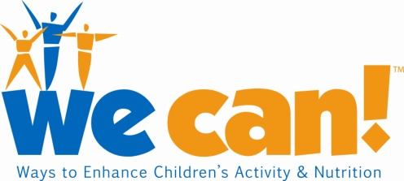 Say We Can!TM
Public Service Announcement
Radio or Television
:30
____________________________________________________________________

Narrator:

Did you know that one out of every six children ages two to 19 is overweight?

And that here in [Insert name of city, county or state], the number of overweight children is [Insert statistic if available; if not, strike this sentence entirely from your script]?

Being overweight as a child can lead to life-long health problems, including diabetes and heart disease. But you can do something to help.

You can join the National Institute of Health’s We Can! national education movement.

We Can! stands for “Ways to Enhance Children’s Activity and Nutrition” and provides tips and resources to make healthier food choices, increase physical activity, and reduce television, video, and computer screen time—all things that can make the whole family healthier.

To learn more about the movement’s flexible, easy-to-use, science-based programs…

Download free tips and checklists for families …

And find out if one of We Can!’s more than 1,000 registered community sites is near you…

Call 1-866-35-WECAN.

Or visit the Web site at wecan.org.

Yes. You can make a difference.

[Note: This sample script for a radio PSA can be customized for television, too.]

We Can! and the We Can! logo are trademarks of the U.S. Department of Health & Human Services (DHHS).

