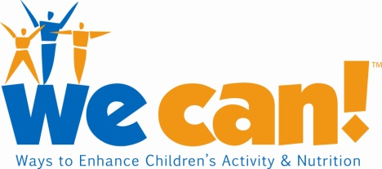 Insert your organization’s logo

For Immediate Release Contact: Name Surname
Month Day, Year Phone # & e-mail address

Insert your organization’s name Joins National Federal Program to Help Parents, Caregivers & Kids Say We Can! Be Healthier

CITY NAME IN ALL CAPS & BOLD, STATE ABBREVIATION (Month Day, Year) – Today, Insert name of your organization joined We Can! (Ways to Enhance Children's Activity & Nutrition), a science-based, National Institutes of Health (NIH) movement that teaches parents, caregivers, kids and communities ways to eat healthier, increase physical activity and limit screen time to help children ages eight through 13 maintain a healthy weight.

“In We Can! we’ve found an easy-to-use, science-based program that not only provides us with valuable resources—it also lets us tap into the expertise of more than a thousand other communities that are already committed to using the program to help overcome weight gain in their communities,” said Insert name and title of your organization’s spokesperson.

According to the U.S. Centers for Disease Control and Prevention’s National Health and Nutrition Examination Surveys (2003-2006), a record one in six children and youth between the ages of two and 19 are overweight. In addition, obesity has more than doubled in this age group since 1980. In X—Insert name of your town, city or county, Y percent Insert local of children ages Insert age range are estimated to be overweight, according to [Cite local source of statistics , such as the Dept. of Health].

“Our community needs tools and tips on how to put our kids—and ourselves—back on the road to healthy weight,” said Insert name and brief description of participating parent or caregiver. “That’s why I am so excited that we’ve become part of the We Can! movement. It will benefit all of us.”

“We Can! is designed to empower parents and communities such as [Insert name of your city/town/county] to adopt healthier lifestyles by offering programs and materials based on the latest obesity prevention research,” said Karen Donato, S.M., coordinator of overweight and obesity research applications for the NIH’s National Heart, Lung, and Blood Institute (NHLBI) and We Can! project coordinator.

We Can! is spearheaded by NHLBI and three other NIH institutes—the National Institute of Diabetes and Digestive and Kidney Diseases, the Eunice Kennedy Shriver National Institute of Child Health and Human Development and the National Cancer Institute. More than 1,000 sites in all 50 states and the District of Columbia, and 11 other countries, have committed to using We Can!, with new sites continuing to sign up regularly.

For more details on We Can!, visit HREF="http://wecan.nhlbi.nih.gov/" or call toll-free at 866-35-WE CAN.

The National Institutes of Health (NIH)—the Nation's Medical Research Agency—includes 27 Institutes and Centers and is a component of the U.S. Department of Health and Human Services. It is the primary federal agency for conducting and supporting basic, clinical and translational medical research, and it investigates the causes, treatments and cures for both common and rare diseases. For more on the NIH, visit http://www.nih.gov.

###

We Can! and the We Can! logo are trademarks of the U.S. Department of Health & Human Services (DHHS).

